COMPUTER GRAPHICS
CRT
CRT (Cathode Ray Tube) is a display device used in early computer monitors and televisions to display images using an electron beam. It works by striking phosphor-coated screen with electrons to produce light.
Types of CRT
1. Raster Scan CRT
- Beam moves line by line
- Used in TV and monitors
- Image stored in frame buffer
2. Random Scan CRT (Vector Display)
- Draws lines directly
- Used in CAD systems
- Higher resolution for line drawings
Advantages
- Good color quality
- Wide viewing angle
- Fast response time
- Smooth motion display
Disadvantages
- Bulky and heavy
- High power consumption
- Generates heat
- Radiation emission
- Flickering problem
Block diagram
Electron Gun → Control Grid → Focusing System → Deflection Plates → Phosphor Screen
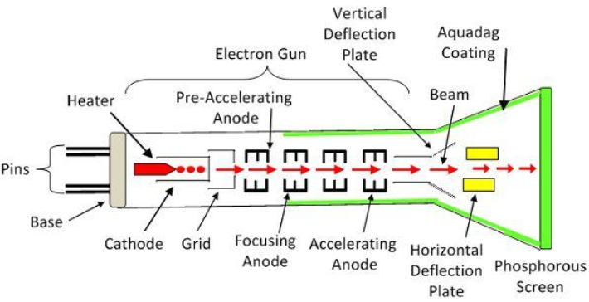

Components of CRT
1. Electron Gun
- Produces electrons
- Acts as the source of electron beam
- Consists of:
  - Heater
  - Cathode
  - Control grid
2. Control Grid
- Controls brightness of the image
- Regulates number of electrons reaching screen
3. Focusing System
- Focuses electron beam into a sharp point
- Helps in producing clear image
4. Deflection System
- Moves electron beam across screen
- Two types:
  - Horizontal deflection plates
  - Vertical deflection plates
5. Phosphor-Coated Screen
- Emits light when struck by electron beam
6. Glass Envelope
- Vacuum tube enclosing all components
- Prevents electron collision with air molecules
LCD:
LCD is a display device that uses liquid crystal material and polarized light to produce images on a flat screen.
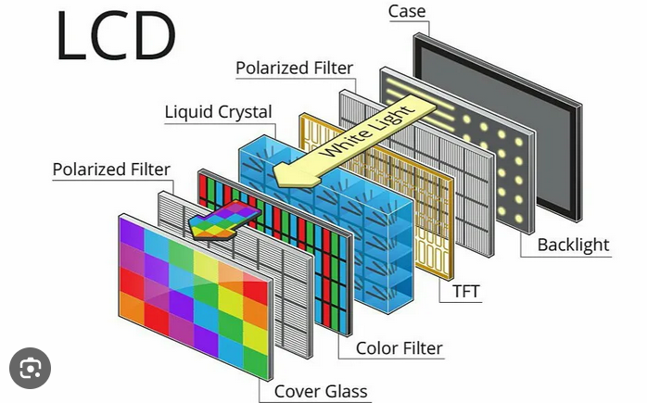
Components of LCD
1. Liquid Crystal Layer
- Main component of LCD
- Controls light passing through screen
2. Polarizing Filters
- Allow only specific light waves to pass
3. Glass Substrates
- Hold liquid crystal material between them
4. Electrodes
- Control pixel brightness
5. Backlight
- Source of light in LCD
- Usually fluorescent lamp
- LCD does not produce light itself
6. Color Filters
- Red, Green, Blue (RGB) filters
Working of LCD
- Backlight produces white light
- Light passes through first polarizer
- Liquid crystals rotate light depending on voltage
- Second polarizer either blocks or allows light
- Color filters add RGB color
- Final image appears on screen
LED:
LED display is a display device that uses light-emitting diodes to produce light and display images.
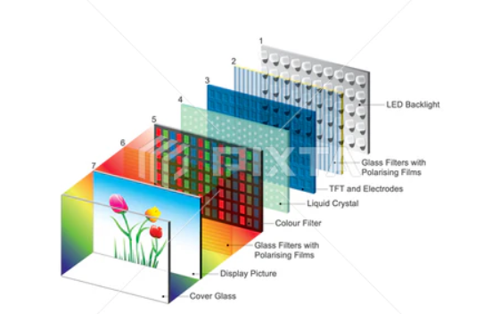
Components of LED Display
1. LED Backlight
- Main light source
- Uses small light emitting diodes
2. Liquid Crystal Layer
- Controls light passing through pixels
3. Polarizing Filters
- Control light direction
4. Glass Panels
- Hold liquid crystal material
5. Color Filters
- Red, Green, Blue filters
6. Driver Circuit
- Controls brightness and pixels
Working of LED Display
- LED backlight emits light
- Light passes through polarizer
- Liquid crystals control light flow
- Second polarizer filters light
- RGB filters create colors
- Image appears on screen

Random Scan :
Electron beam directly draws lines on the screen instead of scanning the whole screen line-by-line.
Raster scan:
Electron beam scans the screen line by line from top to bottom to form an image.

Refresh rate
It is the frequency at which the display screen is refreshed to display the image continuously.
Unit: Hertz (Hz)
Resolution
It is the total number of pixels that can be displayed on a screen, usually expressed as rows × columns.
Frame Buffer
It is a memory area that stores pixel values for display.
Hard-Copy Devices
Hard-copy devices are output devices that produce permanent output on paper or other physical media.
A printer is a hard-copy output device that prints text and graphics on paper.
A plotter is a hard-copy output device used to produce high-quality line drawings and large graphics.
Graphics software
It is a program used to create, edit, manipulate, and display images or drawings on a computer.

Types of Graphics Software
1. Painting Software
- Used to draw freehand pictures
Eg. Microsoft Paint
2. Drawing Software
- Used to create shapes and technical drawings
Eg Adobe Illustrator
3. Image Editing Software
- Used to edit photos
- Adjust color, brightness, effects
Eg. Adobe Photoshop
4. Animation Software
- Used to create moving graphics
Eg Blender
5. CAD Software
- Used for engineering and architectural design
- High precision drawings

Boundary Fill:
Boundary fill algorithm fills an area with a specified color until the boundary color is encountered.
Start from an interior point
Fill pixels with fill color
Stop when boundary color is found

Flood fill:
Flood Fill Algorithm is used to fill a region with a new color by replacing all connected pixels of the same color.

What is Viewing?
Viewing is the process of displaying a selected part of a scene on the output device (screen).
It is similar to looking at a scene through a camera window.
We define:
- What part to see (Window)
- Where to display it (Viewport)
Steps involved:
- World Coordinate System
- Window Selection
- Window-to-Viewport Transformation
- Viewport Display
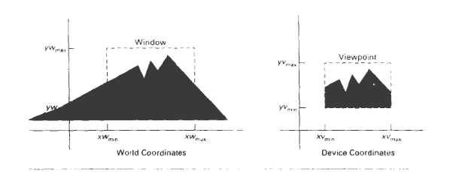
Window:
Window is a rectangular region in world coordinate system that specifies which part of the scene we want to display.
A window is defined by four parameters:
$$(x_{w}^{min},y_{w}^{min})\text{Lower-left corner} \\ (x_{w}^{max},y_{w}^{max})\text{Upper-right corner}$$
So window is written as:
$$W=(x_{w}^{min},y_{w}^{min},x_{w}^{max},y_{w}^{max})$$

Window Transformation Steps
- Define window
- Clip objects outside window
- Map window → viewport
- Display result

Viewport:
Viewport is the rectangular area on the display device where the selected window is mapped and displayed.
Viewport is defined using screen/device coordinates:
$$(x_{v}^{min},y_{v}^{min})\text{Lower-left corner} \\ (x_{v}^{max},y_{v}^{max})\text{Upper-right corner}$$
So viewport is:
$$V=(x_{v}^{min},y_{v}^{min},x_{v}^{max},y_{v}^{max})$$

World Coordinate System:
World Coordinate System is a logical coordinate system used to define objects in a scene independent of display device.
Device Coordinate System:
Device Coordinate System is the physical coordinate system of the output device (screen, printer, plotter).

Window to Viewport Transformation
process of mapping a selected area of the world coordinate system (window) onto a specific area of the display device (viewport).
Window (in World Coordinates):
Defined by four parameters:
$$x_{w}^{min}, y_{w}^{min} \\ x_{w}^{max}, y_{w}^{max}$$
Width of window:
$$W_{w}=x_{w}^{max}-x_{w}^{min}$$
Height of window:
$$H_{w}=y_{w}^{max}-y_{w}^{min}$$
Viewport (in Device Coordinates):
Defined by:
$$x_{v}^{min}, y_{v}^{min} \\ x_{v}^{max}, y_{v}^{max}$$
Width of viewport:
$$W_{v}=x_{v}^{max}-x_{v}^{min}$$
Height of viewport:
$$H_{v}=y_{v}^{max}-y_{v}^{min}$$

Scaling Factors:
Horizontal scale:
$$S_{x}=\frac{x_{v}^{max}-x_{v}^{min}}{x_{w}^{max}-x_{w}^{min}}$$
Vertical scale:
$$S_{y}=\frac{y_{v}^{max}-y_{v}^{min}}{y_{w}^{max}-y_{w}^{min}}$$

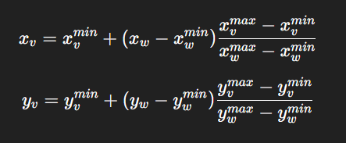
Viewing Pipeline:
Viewing Pipeline is the sequence of steps used to convert objects from world coordinates to screen coordinates for display.
Viewing Pipeline Steps
World Coordinates
↓
Window Selection
↓
Clipping
↓
Window-to-Viewport Transformation
↓
Device Coordinates

Clipping
Clipping is the process of removing the parts of objects that lie outside the viewing area (window) and displaying only the visible portion.
Only the part inside the window is kept
Outside part is discarded
clipping window
A Clipping Window is a rectangular region in world coordinate system that defines the area inside which objects are visible.
Any part of an object outside this window is clipped (removed).
point clipping
Point Clipping is the process of checking whether a point lies inside the clipping window or outside it.
A point $P(x,y)$is visible if:
$$x_{min}≤x≤x_{max} \\ y_{min}≤y≤y_{max}$$
Line Clipping
Line Clipping is the process of removing the portion of a line that lies outside the clipping window and displaying only the visible part inside the window.

